**Министерство образования и науки**

**Российской Федерации**

**САНКТ-ПЕТЕРБУРГСКИЙ НАЦИОНАЛЬНЫЙ ИССЛЕДОВАТЕЛЬСКИЙ УНИВЕРСИТЕТ ИТМО**

Факультет программной инженерии и компьютерной техники

Дисциплина: Дискретная математика

**Курсовая работа часть 1**

Вариант 98

Выполнил студент группы Р3133 Анисимов Максим Дмитриевич

Проверил Поляков Владимир Иванович

Санкт-Петербург

2022 г

Условия, при которых f=1: (x4x5+x1x2x3)=1, 5, 8, 10

Условия, при которых f=d: (x1x2x3)=0

**Таблица истинности**

|  |  |  |  |  |  |  |  |
| --- | --- | --- | --- | --- | --- | --- | --- |
| N | X1X2X3X4X5 | X4X5 | (X4X5)10 | X1X2X3 | (X1X2X3)10 | |+| | f |
| 0 | 00000 | 00 | 0 | 000 | 0 | 0 | d |
| 1 | 00001 | 01 | 1 | 000 | 0 | 1 | D |
| 2 | 00010 | 10 | 2 | 000 | 0 | 2 | d |
| 3 | 00011 | 11 | 3 | 000 | 0 | 3 | D |
| 4 | 00100 | 00 | 0 | 001 | 1 | 1 | 1 |
| 5 | 00101 | 01 | 1 | 001 | 1 | 2 | 0 |
| 6 | 00110 | 10 | 2 | 001 | 1 | 3 | 0 |
| 7 | 00111 | 11 | 3 | 001 | 1 | 4 | 0 |
| 8 | 01000 | 00 | 0 | 010 | 2 | 2 | 0 |
| 9 | 01001 | 01 | 1 | 010 | 2 | 3 | 0 |
| 10 | 01010 | 10 | 2 | 010 | 2 | 4 | 0 |
| 11 | 01011 | 11 | 3 | 010 | 2 | 5 | 1 |
| 12 | 01100 | 00 | 0 | 011 | 3 | 3 | 0 |
| 13 | 01101 | 01 | 1 | 011 | 3 | 4 | 0 |
| 14 | 01110 | 10 | 2 | 011 | 3 | 5 | 1 |
| 15 | 01111 | 11 | 3 | 011 | 3 | 6 | 0 |
| 16 | 10000 | 00 | 0 | 100 | 4 | 4 | 0 |
| 17 | 10001 | 01 | 1 | 100 | 4 | 5 | 1 |
| 18 | 10010 | 10 | 2 | 100 | 4 | 6 | 0 |
| 19 | 10011 | 11 | 3 | 100 | 4 | 7 | 0 |
| 20 | 10100 | 00 | 0 | 101 | 5 | 5 | 1 |
| 21 | 10101 | 01 | 1 | 101 | 5 | 6 | 0 |
| 22 | 10110 | 10 | 2 | 101 | 5 | 7 | 0 |
| 23 | 10111 | 11 | 3 | 101 | 5 | 8 | 1 |
| 24 | 11000 | 00 | 0 | 110 | 6 | 6 | 0 |
| 25 | 11001 | 01 | 1 | 110 | 6 | 7 | 0 |
| 26 | 11010 | 10 | 2 | 110 | 6 | 8 | 1 |
| 27 | 11011 | 11 | 3 | 110 | 6 | 9 | 0 |
| 28 | 11100 | 00 | 0 | 111 | 7 | 7 | 0 |
| 29 | 11101 | 01 | 1 | 111 | 7 | 8 | 1 |
| 30 | 11110 | 10 | 2 | 111 | 7 | 9 | 0 |
| 31 | 11111 | 11 | 3 | 111 | 7 | 10 | 1 |

**Аналитический вид**

_ _ _ _ _ _ _ _

**КДНФ**: f=(x1∧x2∧x3∧x4∧x5) ∨ (x1∧x2∧x3∧x4∧x5) ∨ (x1∧x2∧x3∧x4∧x5) ∨

_ _ _ _ _ _ _

(x1∧x2∧x3∧x4∧x5) ∨(x1∧x2∧x3∧x4∧x5) ∨ (x1∧x2∧x3∧x4∧x5) ∨

_ _ _

(x1∧x2∧x3∧x4∧x5) ∨ (x1∧x2∧x3∧x4∧x5) ∨ (x1∧x2∧x3∧x4∧x5)

_ _ _ _ _ _ _

**ККНФ**: f=(x1∨x2∨x3∨x4∨x5)(x1∨x2∨x3∨x4∨x5)(x1∨x2∨x3∨x4∨x5)

_ _ _ _ _

(x1∨x2∨x3∨x4∨x5)(x1∨x2∨x3∨x4∨x5)(x1∨x2∨x3∨x4∨x5)

_ _ _ _ _ _ _ _ _

(x1∧x2∧x3∧x4∧x5)(x1∧x2∧x3∧x4∧x5)(x1∧x2∧x3∧x4∧x5)

_ _ _ _ _ _ _ _ _

(x1∧x2∧x3∧x4∧x5)(x1∧x2∧x3∧x4∧x5)(x1∧x2∧x3∧x4∧x5)(x1∧x2∧x3∧x4∧x5)

_ _ _ _ _ _ _ _ _ _ _ _

(x1∧x2∧x3∧x4∧x5)(x1∧x2∧x3∧x4∧x5)(x1∧x2∧x3∧x4∧x5)(x1∧x2∧x3∧x4∧x5)

_ _ _ _ _ _ _

(x1∧x2∧x3∧x4∧x5) (x1∧x2∧x3∧x4∧x5)

**Минимизация булевой функции методом Квайна-Мак-Класки**

**Кубы различной размерности и простые импликанты**

|  |  |  |  |  |  |  |  |  |  |  |  |  |
| --- | --- | --- | --- | --- | --- | --- | --- | --- | --- | --- | --- | --- |
| **№** | **K0** |  | **№** | **K1** |  |  | **№** | **K2** |  |  | **№** | **Z(f)** |
| 1 | 00000 | ✓ | 1 | 0000Х | 1-2 | ✓ | 1 | 000ХХ | 2-4 | 1-6 | 1 | 01110 |
| 2 | 00001 | ✓ | 2 | 000Х0 | 1-3 | ✓ |  |  |  |  | 2 | 11010 |
| 3 | 00010 | ✓ | 3 | 00X00 | 1-5 |  |  |  |  |  | 3 | 00X00 |
| 4 | 00011 | ✓ | 4 | 000X1 | 2-4 | ✓ |  |  |  |  | 4 | X0001 |
| 5 | 00100 | ✓ | 5 | X0001 | 2-8 |  |  |  |  |  | 5 | 0X011 |
| 6 | 01011 | ✓ | 6 | 0001X | 3-4 | ✓ |  |  |  |  | 6 | X0100 |
| 7 | 01110 |  | 7 | 0X011 | 4-6 |  |  |  |  |  | 7 | 1X111 |
| 8 | 10001 | ✓ | 8 | X0100 | 5-9 |  |  |  |  |  | 8 | 111X1 |
| 9 | 10100 | ✓ | 9 | 1X111 | 10-13 |  |  |  |  |  | 9 | 000XX |
| 10 | 10111 | ✓ | 10 | 111X1 | 12-13 |  |  |  |  |  |  |  |
| 11 | 11010 |  |  |  |  |  |  |  |  |  |  |  |
| 12 | 11101 | ✓ |  |  |  |  |  |  |  |  |  |  |
| 13 | 11111 | ✓ |  |  |  |  |  |  |  |  |  |  |

**Таблица импликант**

|  |  |  |  |  |  |  |  |  |  |
| --- | --- | --- | --- | --- | --- | --- | --- | --- | --- |
| Простые импликанты | 0  0  1  0  0 | 0  1  0  1  1 | 0  1  1  1  0 | 1  0  0  0  1 | 1  0  1  0  0 | 1  0  1  1  1 | 1  1  0  1  0 | 1  1  1  0  1 | 1  1  1  1  1 |
| 01110 |  |  | X |  |  |  |  |  |  |
| 11010 |  |  |  |  |  |  | X |  |  |
| 00X00 | X |  |  |  |  |  |  |  |  |
| X0001 |  |  |  | X |  |  |  |  |  |
| 0X011 |  | X |  |  |  |  |  |  |  |
| X0100 | Х |  |  |  | Х |  |  |  |  |
| 1X111 |  |  |  |  |  | Х |  |  | X |
| 111X1 |  |  |  |  |  |  |  | Х | X |
| 000XX |  |  |  |  |  |  |  |  |  |

Импликанты 1,2,4,5,6, 7, 8, 9 – существенные, так как они покрывают вершины 2,3,4,5,6,7,8

Ядро покрытия:

$T=\left\{\begin{aligned}01110 \\ 11010 \\ Х0001 \\ 0Х011 \\ X0100 \\ 1X111 \\ 111Х1\end{aligned}\right\}$ $С_{min}=\left\{\begin{aligned}01110 \\ 11010 \\ Х0001 \\ 0Х011 \\ X0100 \\ 1X111 \\ 111Х1\end{aligned}\right\}$

Этому покрытию соответствует следующая МДНФ:

_ _ _ _ _ _ _ _ _

F=(x1∧x2∧x3∧x4∧x5) ∨(x1∧x2∧x3∧x4∧x5) ∨ (x2∧x3∧x4∧x5) ∨ (x1∧x3∧x4∧x5) ∨

_ _ _

(x2∧x3∧x4∧x5) ∨ (x1∧x3∧x4∧x5) ∨ (x1∧x2∧x3∧x5)

**Минимизация булевой функции на картах Карно**

**Определение МДНФ**

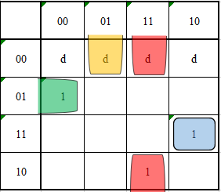

X1=0 X1=1

$$C_{min}=\left\{\begin{aligned}01110 \\ 11010 \\ X0001 \\ 0Х011 \\ Х0100 \\ 1Х111 \\ 111Х1\end{aligned}\right\}$$

Sa=30

Sb=37

_ _ _ _ _ _ _ _ _

F=(x1∧x2∧x3∧x4∧x5) ∨(x1∧x2∧x3∧x4∧x5) ∨(x2∧x3∧x4∧x5) ∨(x1∧x3∧x4∧x5)

_ _ _

∨(x2∧x3∧x4∧x5)∨(x1∧x3∧x4∧x5) ∨(x1∧x2∧x3∧x5)

**Определение МКНФ**

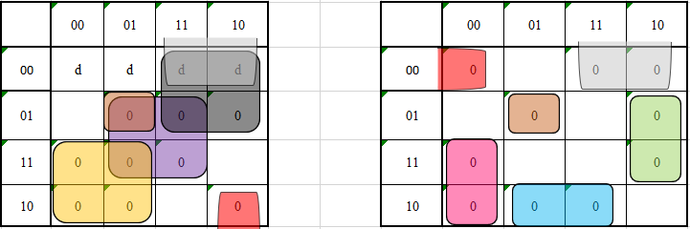

X1=0 X1=1

$$C_{min}=\left\{\begin{aligned}00X1X \\ 0X1X1 \\ 01X0X \\ 1X110 \\ X001X \\ X1X00 \\ 110X1 \\ X0101 \\ XX0X0\end{aligned}\right\}$$

Sa=29

Sb=38

_ _ _ _ _ _ _ _ _

F=(x1∧x4∧x5) ∨(x1∧x3∧x5) ∨(x1∧x2∧x4) ∨(x1∧x3∧x4∧x5)∨(x2∧x3∧x4)∨(x2∧x4∧x5)

_ _ _ _ _

∨(x1∧x2∧x3∧x5) ∨ (x2∧x3∧x4∧x5) ∨(x3∧x5)

**Преобразование минимальных форм булевой функции**

**Факторизация и декомпозиция МДНФ** _ _ _ _ _ _ _ _ _

F=(x1∧x2∧x3∧x4∧x5) ∨(x1∧x2∧x3∧x4∧x5) ∨(x2∧x3∧x4∧x5) ∨(x1∧x3∧x4∧x5)

_ _ _

∨(x2∧x3∧x4∧x5)∨(x1∧x3∧x4∧x5) ∨(x1∧x2∧x3∧x5)

SQ=37

_ _ _ _ _ _ _ _ _

F= x2∧x4∧x5∧(x1∧x3 ∨ x1∧x3) ∨ x2∧x4∧(x3∧x5 ∨ x3∧x5) ∨ (x1∧x3∧x4∧x5) ∨

x1∧x3∧x5∧(x2∨x4)

SQ=29

φ = x2∨x4

_ _ _

φ=x2∧x4

_ _ _ _ _ _ _ _ _

F= x2∧x4∧x5∧(x1∧x3 ∨ x1∧x3) ∨ φ ∧(x3∧x5 ∨ x3∧x5) ∨ (x1∧x3∧x4∧x5) ∨

x1∧x3∧x5∧φ

SQ=29

**Факторизация и декомпозиция МКНФ**

_ _ _ _ _ _ _ _ _

F=(x1∨x4∨x5) ∧ (x1∨x3∨x5) ∧ (x1∨x2∨x4) ∧ (x1∨x3∨x4∨x5) ∧ (x2∨x3∨x4) ∧ (x2∨x4∨x5)

_ _ _ _ _

∨(x1∨x2∨x3∨x5) ∧ (x2∨x3∨x4∨x5) ∧ (x3∧x5)

SQ=38

_ _ _ _ _ _ _

F=( x1∧x3 ∨ x2 ∨ x4) ∧ (x3 ∨ x5 ∨ x1∧(x2 ∨ x4)) ∧ (x2 ∨ x4 ∨ x1∧x5)) ∧ (x1 ∨ x3∧x5 ∨

_ _ _

x3∧x4 ∨ x2∧x4) ∧ (x3∧x5)

SQ= 34

φ = x3∨x5

_ _ _

φ=x3∧x5

_ _ _ _ _ _

F=( x1∧x3 ∨ x2 ∨ x4) ∧ (x3 ∨ x5 ∨ x1∧(x2 ∨ x4)) ∧ (x2 ∨ x4 ∨ x1∧x5)) ∧ (x1 ∨ φ ∨

_ _ _

x3∧x4 ∨ x2∧x4) ∧ φ

SQ= 34

**Синтез комбинационных схем**

**Булев базис**

Схема по упрощённой МДНФ:

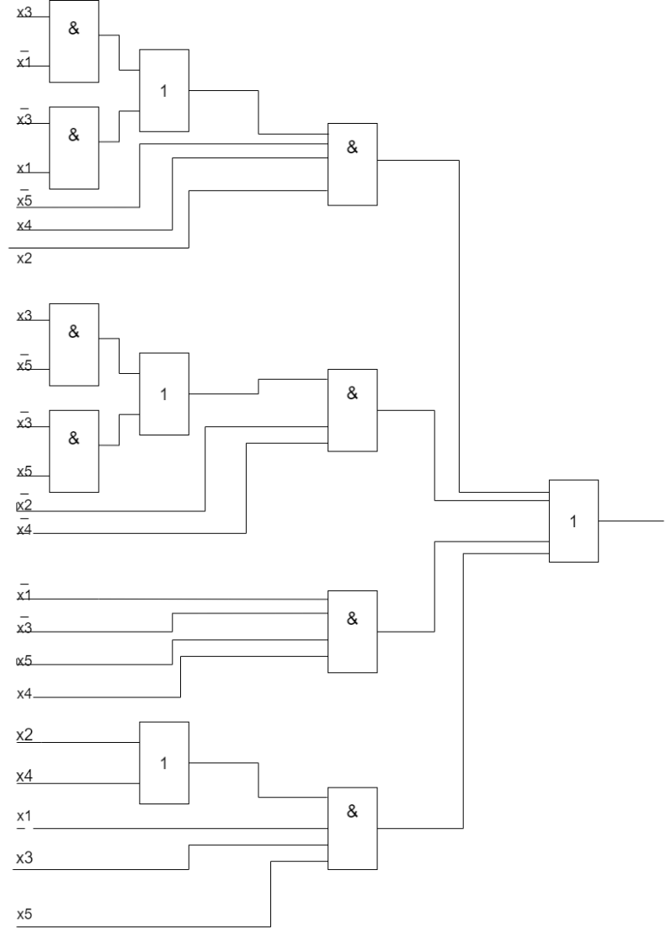

**Сокращенный булев базис (И, НЕ)**

Схема по упрощенной МДНФ в базисе И, НЕ:

_______________________________________________

_________________ ___________ _________ _________

_________ _________

_____ _____ _____ _____

_ _ _ _ _ _ _ _ _

F= x2 x4 x5 x1 x3 x1 x3 φ x3 x5 x3 x5 x1 x3 x4 x5 x1 x3 x5 φ

**Универсальный базис (И-НЕ 2 входа)**

F= (x2|x4| x5| (x1| x3)| (x1| x3))| (φ| (x3| x5)| (x3| x5))|(x1| x3| x4| x5)| (x1| x3 |x5| φ) =

_________________________________________________

_________________ ___________

_________ _________

____ ____ ____ ____

_________ _________

_ _ _ _ _ _ _ _ _

x2 x4 x5 x1 x3 x1 x3 φ x3 x5 x3 x5 x1 x3 x4 x5 x1 x3 x5 φ

